Instructions for Processing Audio Stimuli

1. Load files in Audacity by pressing File > Open and selecting all the raw audio files.
2. Reduce noise: Select just a portion of the background noise (you can select a portion of the sound by clicking and dragging). For example (the light blue portion is the portion I selected):

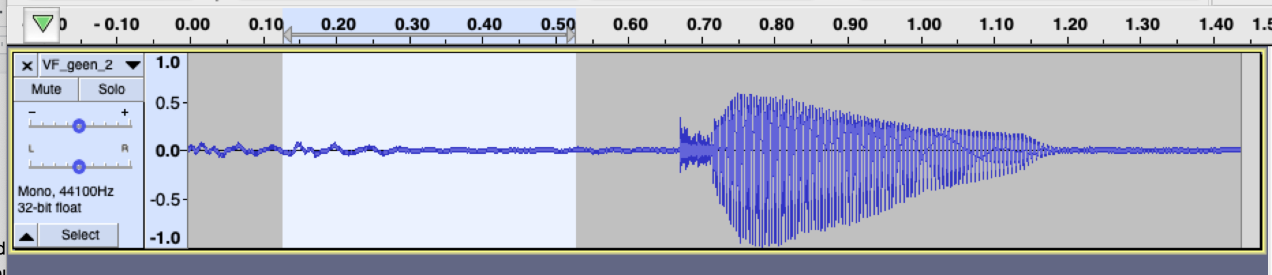

Press Effect > Noise Reduction… Then press Get Noise Profile.

Then, select the entire sound (double-click):

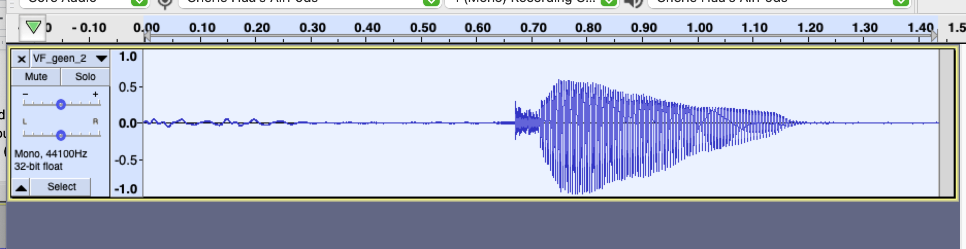

and click Effect > Noise Reduction… again, but this time press OK. You should see the sound change slightly. (You could also just press control R instead to repeat noise reduction)

1. Cut the audio file to just the sound by selecting the portion you want to cut and pressing this icon:

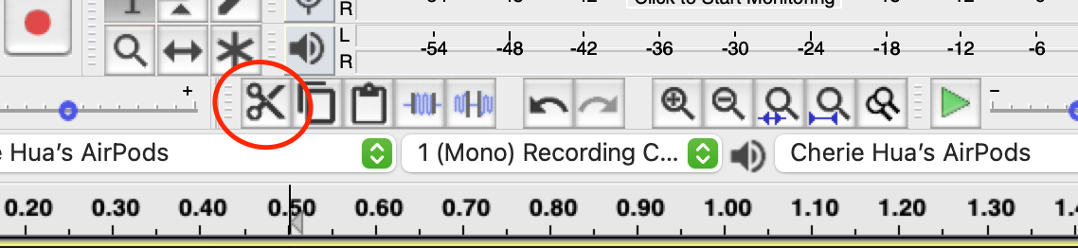

or the backspace key. You can listen to the sound a couple times by clicking where you want to start listening from and pressing the green play button.

I usually cut it down to something like this:

* + - * 1. Optionally, you can use Effect > Truncate Noise to do some automatic noise truncation, but manual adjustment will likely be necessary afterwards.

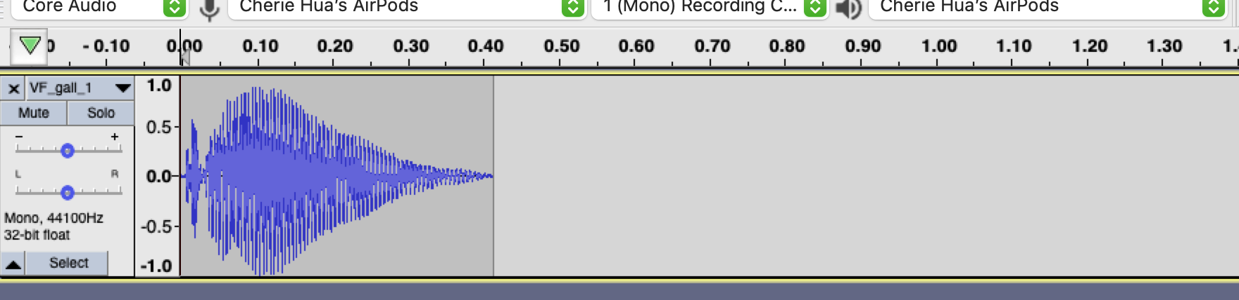

1. To export the file, click File > Export > Export as WAV. Then when it prompts you to name the artist name, album, etc. just click OK. Then when you close the file and it asks if you want to save changes to the project, I don’t since I don’t really see a point, but you can if you want.
   1. File > Export > Export Multiple… is faster 😊
2. Repeat steps 2-4 for all the files.
   1. Noise reduction can be done on all sounds automatically (since we can assume the noise is the same across all measurements)
3. Now open Praat. Select Open > Read from file… and select all the processed files.
4. Then select all the sounds and press Process > Change duration and set the new duration to 0.41756 seconds. Use the method Stretch. You should get a bunch of new files with changeduration in the name.
   1. This is available only after installing the Praat Vocal Toolkit (<http://www.praatvocaltoolkit.com/>)
5. To normalize the intensity of sounds, use the effect “Loudness Normalization” to normalize the RMS level to -20 dB.
6. To save multiple files at once in Praat, use this script:

# Start with an input form

form Enter directory to save your sounds

sentence directory /Users/cheriehua/Desktop/psych_stimuli/

endform

# Ask the user to select the sounds they want to save

pause select all sounds you want to save

numberOfSelectedSounds = numberOfSelected ("Sound")

# Assign an object number to each sound

for thisSelectedSound to numberOfSelectedSounds

sound'thisSelectedSound' = selected("Sound",thisSelectedSound)

endfor

# Loop through the sounds

for thisSound from 1 to numberOfSelectedSounds

select sound'thisSound'

name$ = selected$("Sound")

# Old style of Praat coding, but it still works

do ("Save as WAV file...", directory$ + name$ + ".wav")

endfor

#re-select the sounds

select sound1

for thisSound from 2 to numberOfSelectedSounds

plus sound'thisSound'

endfor

Make sure to modify the sentence directory. Select Praat > New Praat Script and copy paste the above into the file. Then you can just press Run.

1. Once you have all the files saved to your computer, you’ll see that all the files have that annoying changeduration_ thing in their names. You can probably modify the Praat script to get rid of this:

Select all the files you want to rename

Right click and select Rename

Replace -changeduration_Stretch__0_41756 with nothing.